Data Model
The Conceptual Model
The conceptual data model for the QI Questionnaire API is as follows;
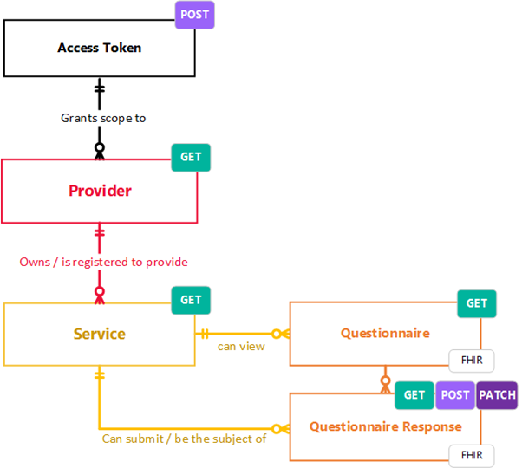
This expands into the following UMLs;
FHIR Questionnaire
This Questionnaire is a based on v5.0.0 version of the HL7 FHIR Questionnaire and QuestionnaireResponse resources. FHIR Questionnaire offers a structured set of questions intended to guide the collection of answers from end-users. Questionnaires provide detailed control over order, presentation, phraseology and grouping to allow coherent, consistent data collection. Structural changes to the QI Questionnaire will be release managed using version increments. QI questions will have immutable codes and linkIDs that will persist whenever possible between QI Questionnaire versions in order to allow for software that interacts with this API to be able to programmatically anticipate how to structure and submit a QuestionnaireResponse.
Questionnaire
A structured set of questions intended to guide the collection of answers from end-users. Questionnaires provide detailed control over order, presentation, phraseology and grouping to allow coherent, consistent data collection.
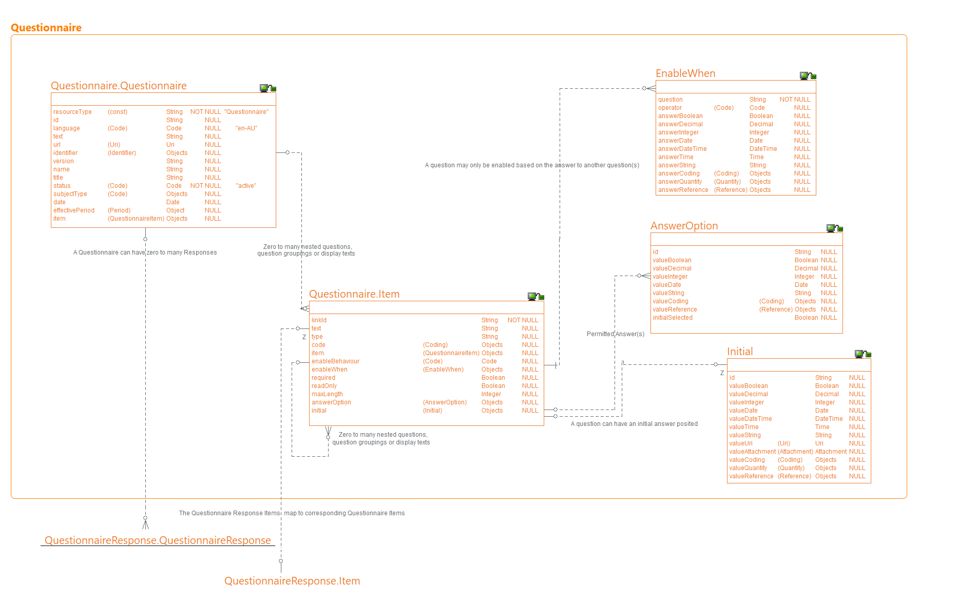
QuestionnaireResponse
A structured set of questions and their answers. The questions are ordered and grouped into coherent subsets, corresponding to the structure of the grouping of the questionnaire.
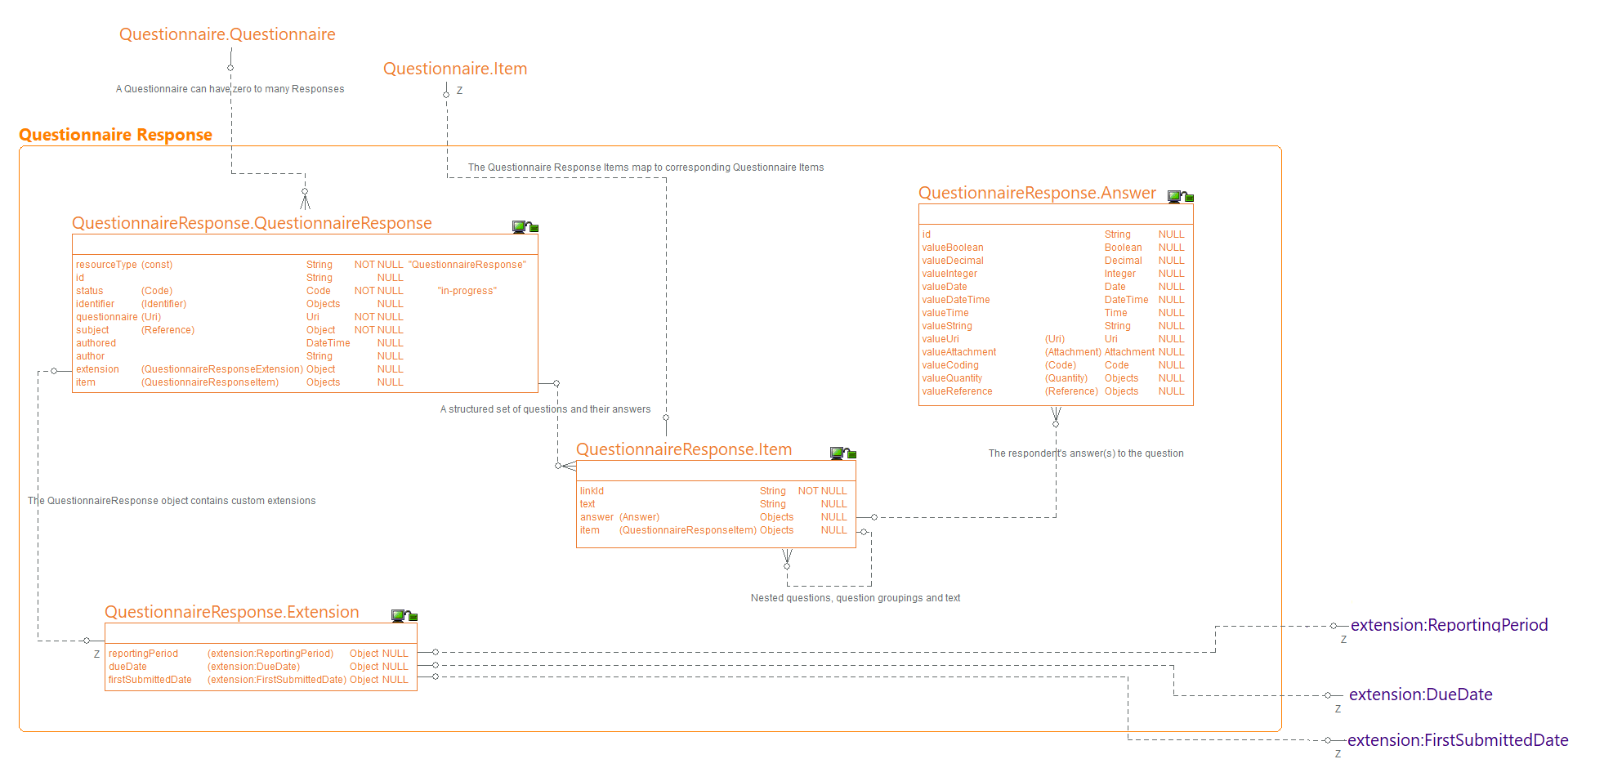
Extensions
The Questionnaire and QuestionnaireResponse are based on the R5 FHIR Specification. As is common with off-the-shelf schemas, the Department needs additional information to be exchanged that is not catered for in the standard model. Given the frequency of this need, extensibility is a fundamental part of the FHIR design. Every resource or datatype may include one or more "extension" child elements. The extension is either simple or complex. Simple extensions have only a value and no nested extensions. Complex extensions contain one or more nested extensions and no value. An extension cannot have both a value and nested extensions.
In this instance, the QuestionnaireResponse has three simple extensions to cater for the need to communicate the reportingPeriod, dueDate, and firstSubmittedDate of the given submission. For examples of how this is realised in the payload, refer to the sample payload via the Mocking Service.
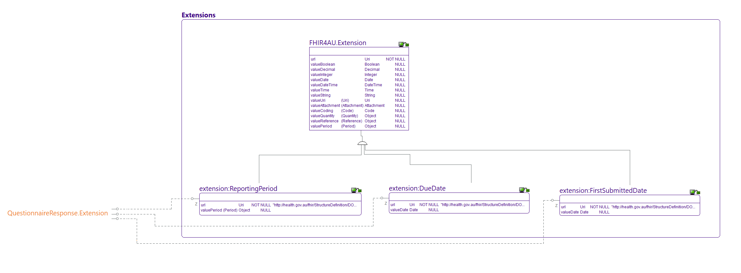
OperationOutcome
The OperationOutcome object is used to report back a collection of error, warning or information messages in response to an API interaction. E.g. when their request contains an error. OperationOutcome is based on the FHIR resource OperationOutcome.
The OperationOutcome resource is used in the following circumstances:
- When a REST interaction or operation fails
- As the response on a validation operation to provide information about the outcome
- As part or all of a message response, usually when the message has not been processed correctly
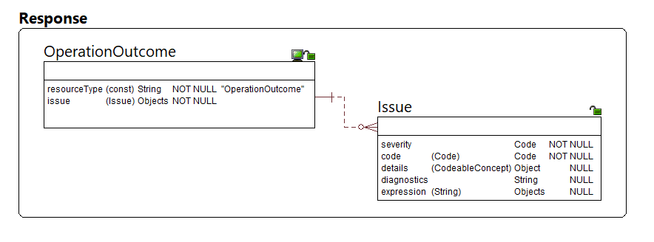
Data Types
The API endpoints built from these data models consist of corresponding resources that in turn are built from Data Types. This API borrows a FHIR standard for defining Complex and Primitive Data Types. The following of which are included in the API definition. Even non-FHIR APIs are built from these RAML fragments/OAS base components to provide a consistent developer experience consuming Department APIs.
Primitive Types
Single simple types which are single elements with a primitive value as below;
Complex Data Types
General purpose complex types which are re-usable clusters of elements as below;
